**Prototype 2 - AWTY**

For our prototype two, we set out to accomplish line following and challenge identification. Coinciding with line following, we aimed to accomplish system alignment with the challenges. In the time leading up to the prototype, the drivers for our stepper motors were blown up, and we were unable to accomplish the line following. In spite of these unfortunate events, two key observations were made: more careful attention needs to be made to how the polarity of power sources are connected and the stepper motors used for driving the vehicle draw too much current for the stepper motor drivers we were using. As such we have established a revised schedule as shown below in **Fig** **1.**

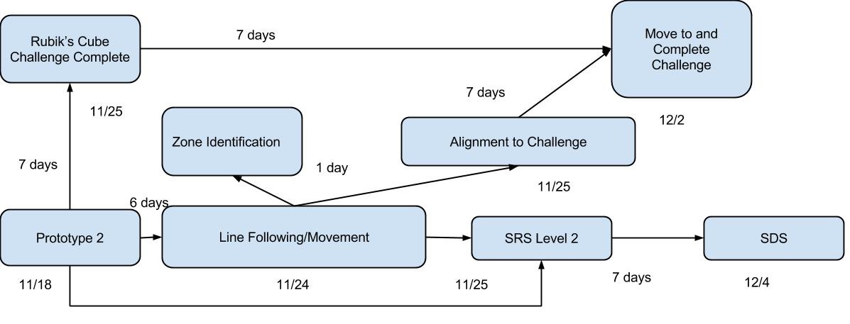

**Fig 1.:** Revised schedule with critical path

From the observations that were made, the following commitments have been made:

* Use standard wiring for all circuit to alleviate any future confusion
* Construct future circuits so that it will be physically impossible to reverse polarity on any power source
* Label all wires on both ends so that they will be properly connected

Looking at what went well during our prototype, we have a chassis that we feel has the potential to be worked on and massaged as ideas grow and change. The chassis is a physical embodiment of how our challenge interactors will be mounted on the system as well as what the overall system will look like so that we can pin-point areas that will require improvement. Furthermore, the object detection aspect of our prototype behaved as expected. It is able to determine how far the system must move to be aligned with the chassis, as well as demonstrating cross communication between the Arduino and the Raspberry Pi to achieve challenge alignment.

While the system did not move, progress has been made in determining what logic and strategies will work best for navigating the course. The aforementioned strategies combined with the object detection and chassis, the system shows potential as a workable design looking towards the future in the form of the final demonstration and the second semester.